| ***Spring Core – Load Country from Spring Configuration XML*** |
| --- |

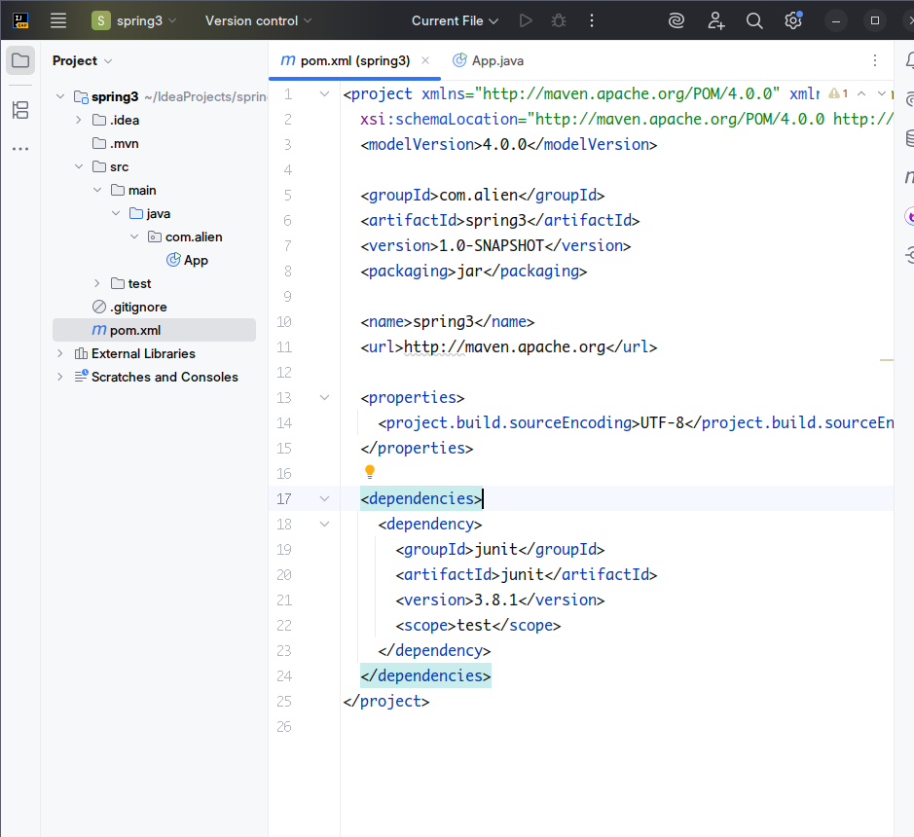

Create an empty Spring Application to make sure we build the country project demo from scratch.

Go to maven repository and search the **Spring Boot Starter (for logging etc) and Spring Context (for traditional configuration)** dependency. and Download the required stable dependency of your choice.

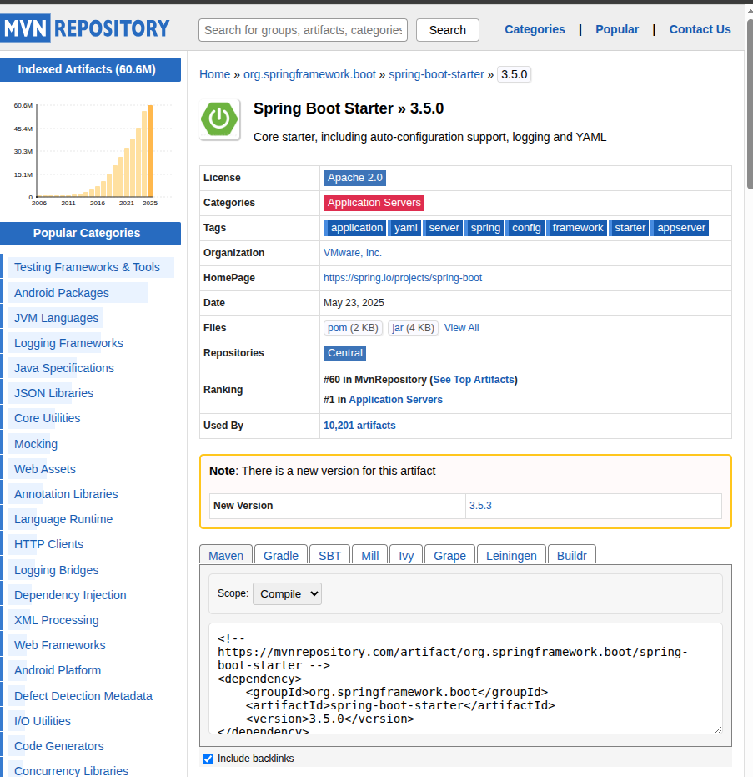

This would make sure that logging and web development features will work properly in the project.

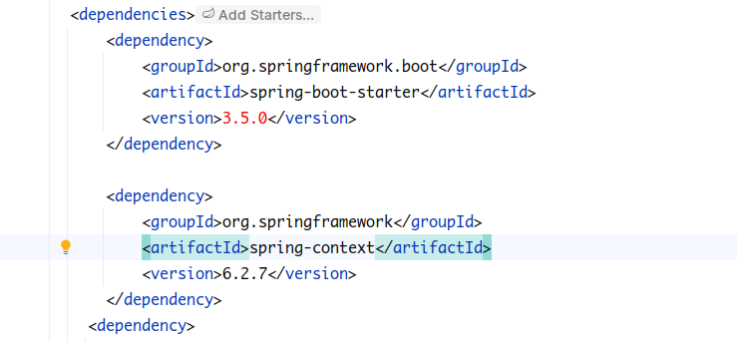

Create a new folder named resources inside the base folder to add a new Spring XML configuration named country.xml.

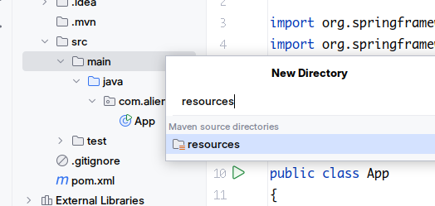

Inside this folder create a new config file named “country.xml”.

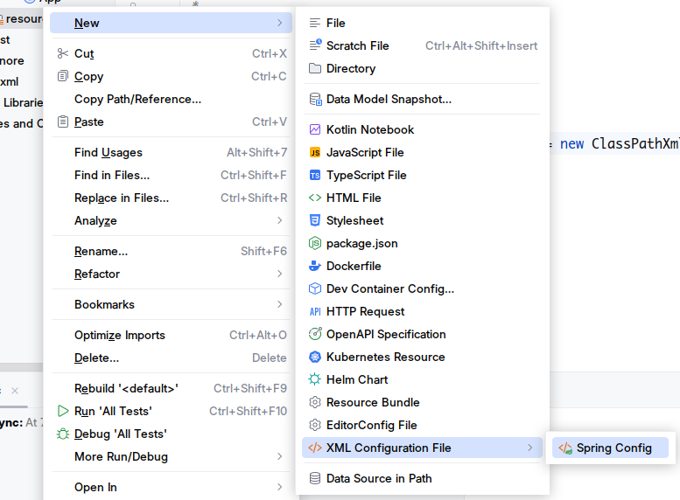

Now lets first create a new class named Country in the base package. So creating bean of the same type would be easier.

The class members are:

Code

Name

Also Generate getter and Setter and toString methods of these members along with the logger debug prints. Keep the MVC structure to ease the configuration process.(optional as suggested by hans-on)

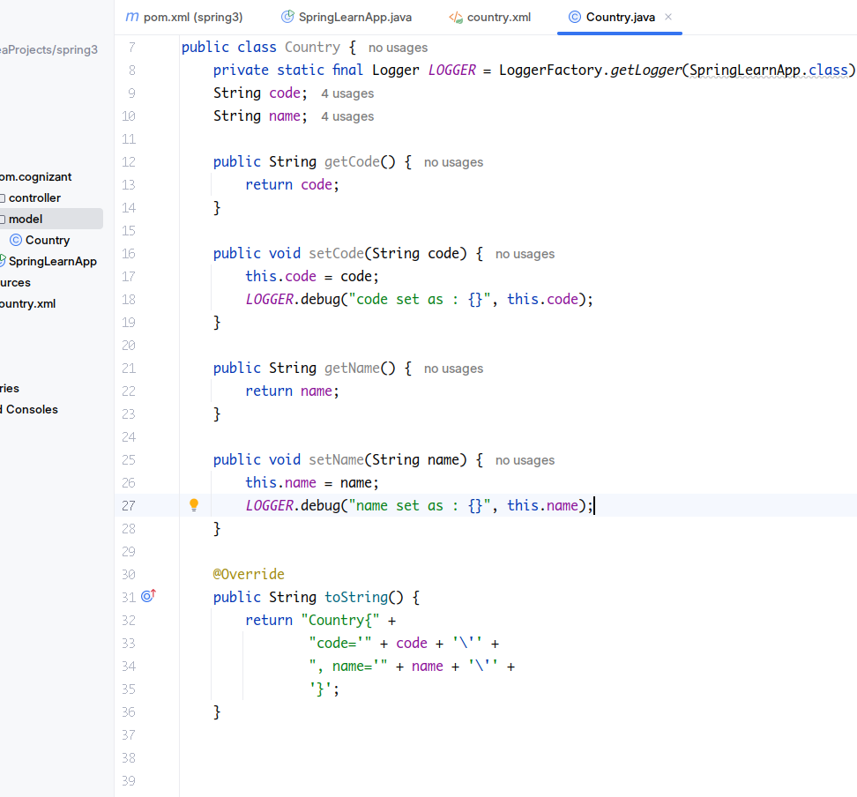

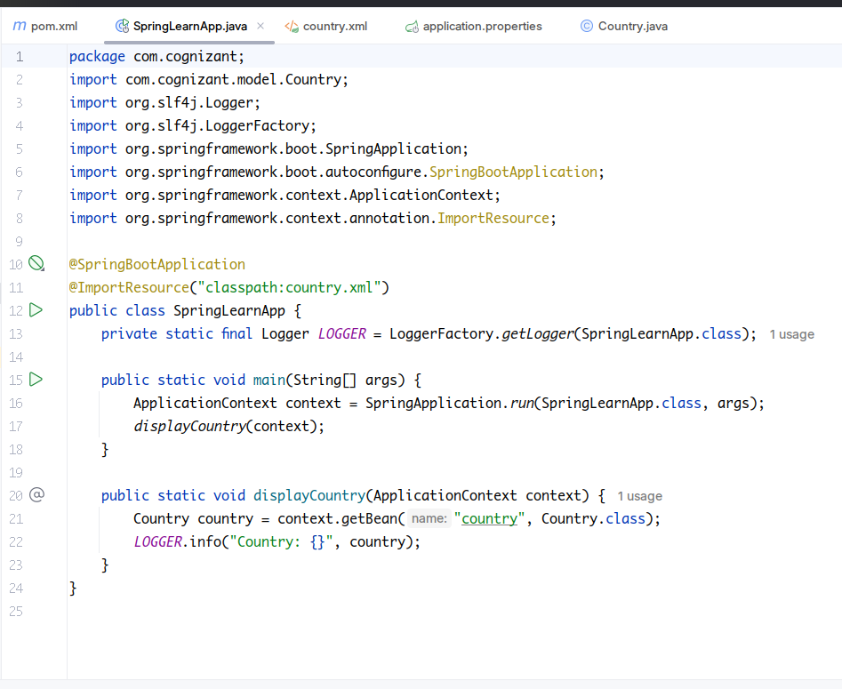

Subsequently create a method displayCountry() in SpringLearnApplication.java, which will read the country bean from the spring configuration file and display the country. We will also create an object of ApplicationContext to get the current running context for fetching beans from the Ioc Container.

Now lets configure out country.xml ->

**Pick any one of your choice country to configure in Spring XML configuration named country.xml.**

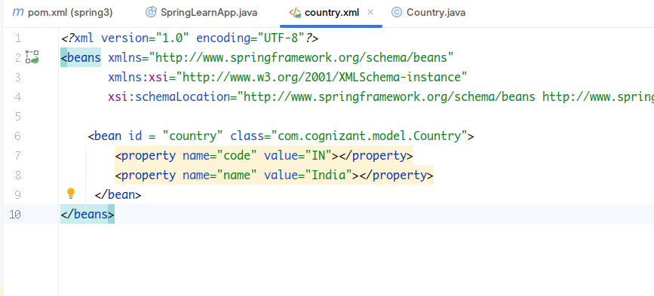

We use the same id here used in Context.getBean(“...”) method. Class equals fully qualified name for the class (may vary).

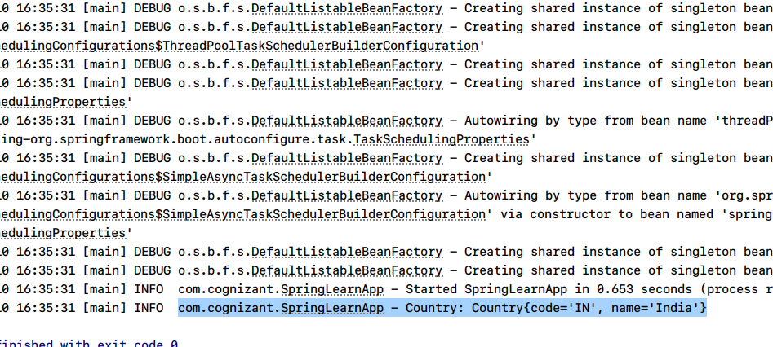

Testing the project ->

The display method runs and prints debug statement of Country object as follows.